Step 1: Understand and Define the Problem (Analyse)
You need to design a combinational logic circuit to activate a LOW-leuel alarm signal
whenever
•The car ignition is ON, and
•Either the driver or the passenger seat is occupied, and
•The corresponding seatbelt is not fastened.
This means.
•If the driver is in the seat and the driver's belt is not fastened, or
•If the passenger is in the seat and the passenger's belt is not fastened,
•And the ignition is ON, the alarm must sound (LOW signal).
Step 2
Symbol | Meaning | Type | Active Logic
DRIV | Driver is in the seat | Input | HIGH (1 = present)
PASS | Passenger is in the seat | Input | HIGH (1 = present)
IGN | Ignition switch is ON | Input | HIGH (1 = on)
BELTD | Driver's seatbelt unfastened | Input | LOW (0 =  unfastened)
BELTP | Passenger's seatbelt unfastened | Input | LOW (0=  unfastened)
ALARM | Alarm signal (active  LOW = sounds when  0) | Output | LOW = ON
3.1 Algorithm (in plain English)
1.Check if the ignition is On
2.Check if driver is seated and driver's belt is not fastened:
•DRIV=1and BELTD^=0
3. Check if passenger is seated and passenger's belt is not fastened:
• PASS= 1 and BELFPA=0
4. If either condition of 2 and 3 is TRUE and IGN =1, then the alarm activates (LOW)
5. Otherwise, alarm remains off (HIGH)

3.2 Truth Table
DRIV | PASS | BELTD^ | BELTP^ | IGN | ALARM
0 | 0 | 0 | 0 | 1 | 1
0 | 0 | 0 | 1 | 1 | 1
0 | 0 | 1 | 0 | 1 | 1
0 | 0 | 1 | 1 | 1 | 1
0 | 1 | 0 | 0 | 1 | 0
0 | 1 | 0 | 1 | 1 | 1
0 | 1 | 1 | 0 | 1 | 0
0 | 1 | 1 | 1 | 1 | 1
1 | 0 | 0 | 0 | 1 | 0
1 | 0 | 0 | 1 | 1 | 0
1 | 0 | 1 | 0 | 1 | 1
1 | 0 | 1 | 1 | 1 | 1
1 | 1 | 0 | 0 | 1 | 0
1 | 1 | 0 | 1 | 1 | 0
1 | 1 | 1 | 0 | 1 | 0
1 | 1 | 1 | 1 | 1 | 1
3.3 SOP
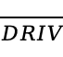 pass 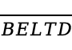 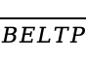 IGN
pass BELTD IGN
DRIV 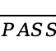 IGN
DRIV BELTP IGN
DRIV pass IGN
DRIV pass BELTP IGN
DRIV pass BELTD IGN
3.4 Flowchart
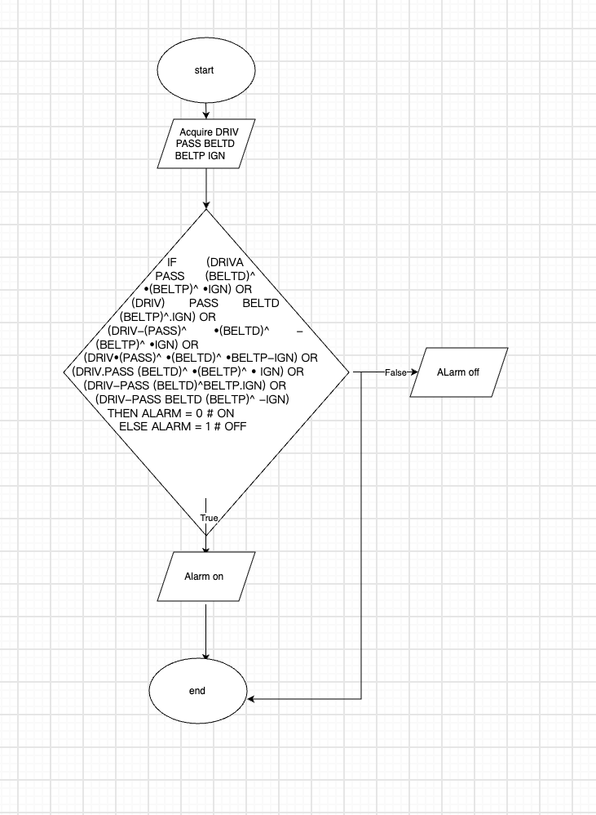
3.5 Pseudocode
IF (DRIVA PASS (BELTD)^ •(BELTP)^ •IGN) OR
(DRIV) PASS BELTD (BELTP)^.IGN) OR
(DRIV-(PASS)^ •(BELTD)^ -(BELTP)^ •IGN) OR
(DRIV•(PASS)^ •(BELTD)^ •BELTP-IGN) OR
(DRIV.PASS (BELTD)^ •(BELTP)^ • IGN) OR
(DRIV-PASS (BELTD)^BELTP.IGN) OR
(DRIV-PASS BELTD (BELTP)^ -IGN)
THEN ALARM = 0 # ON
ELSE ALARM = 1 # OFF

